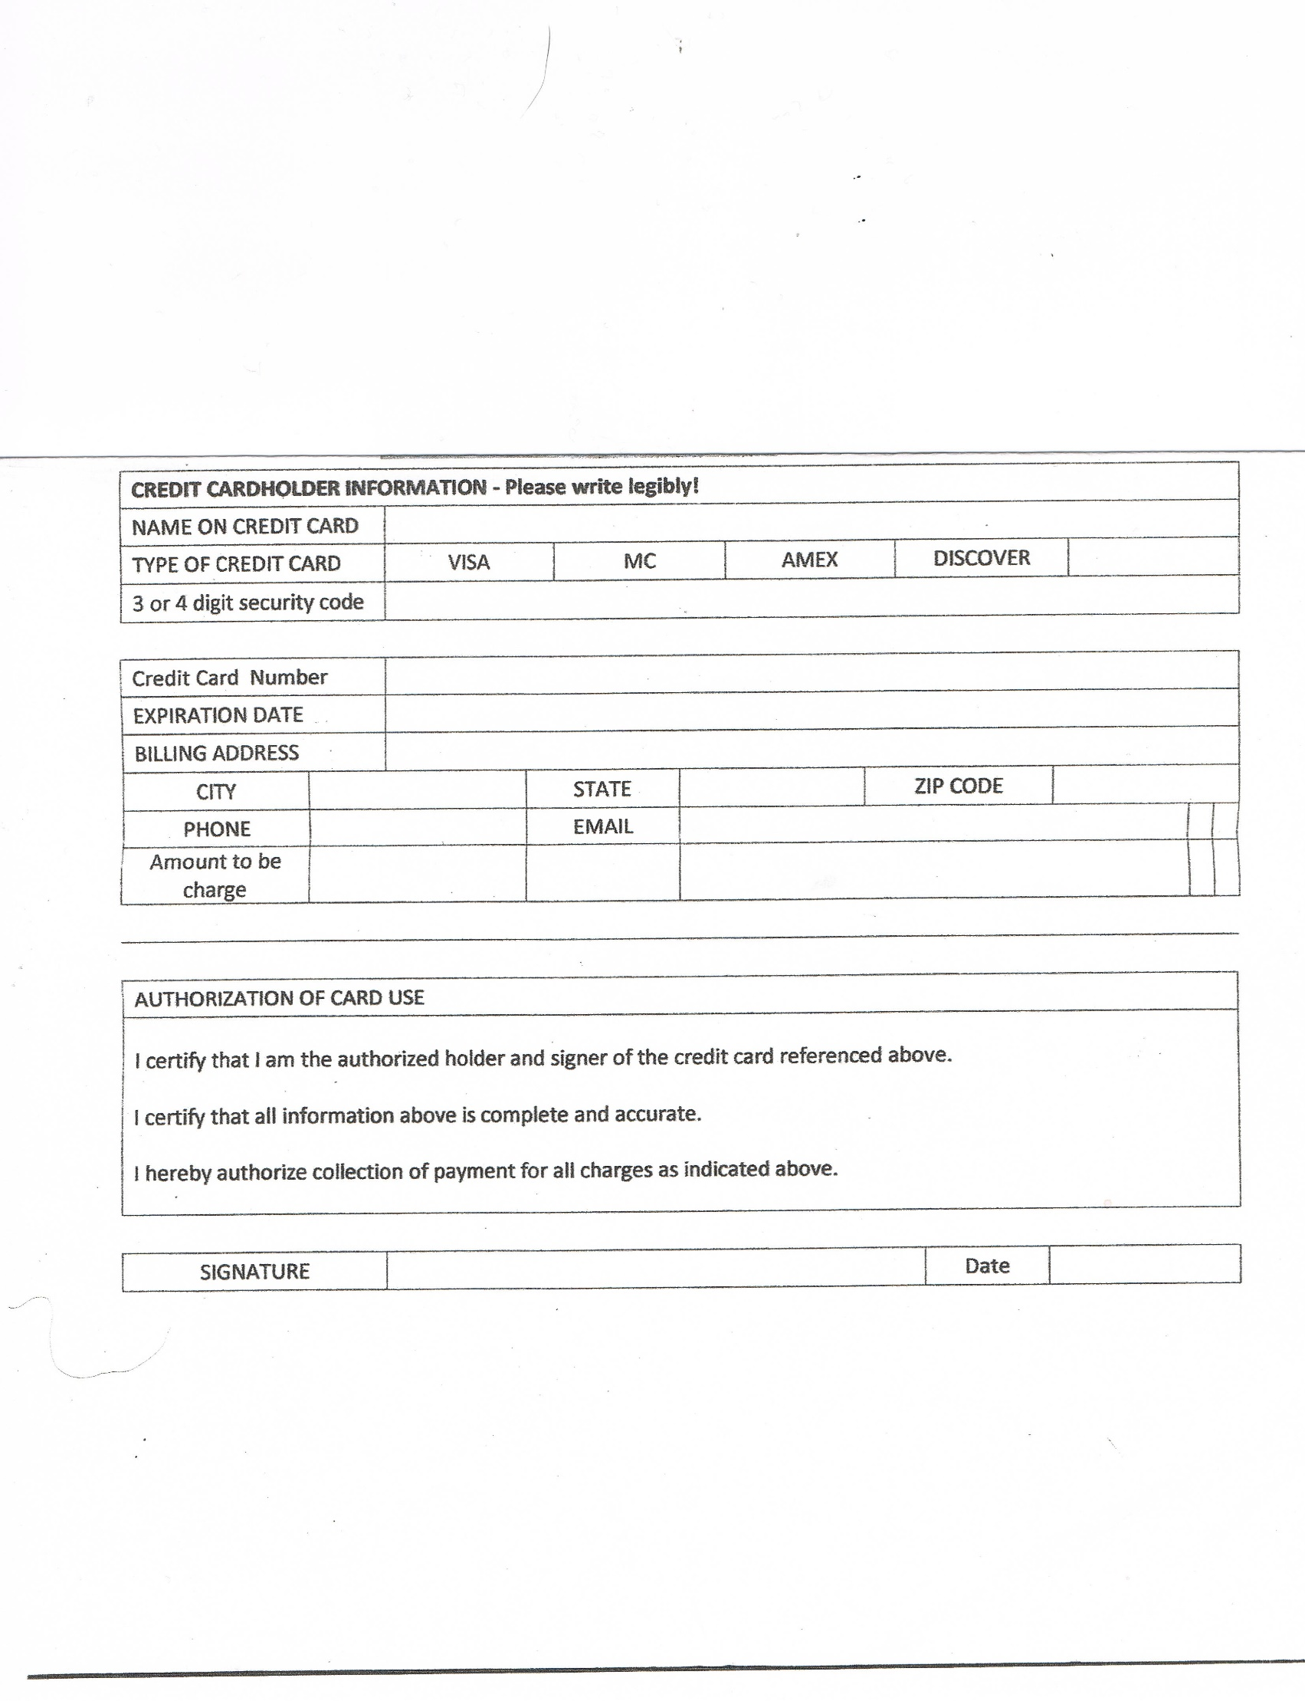

Conference Year ________________