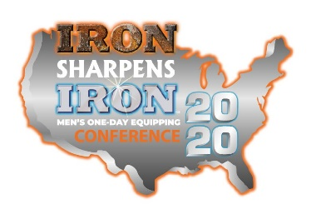
Iron Sharpens Iron 2020 - Jacksonville, FL
2501 Loretto Road, Mandarin Presbyterian Church Campus
Saturday, March 7th 8:30 AM to 4:55 PM
Early Group Sign-up ends Wed, Feb 26th
Adults = $44; Student/Active Military/River Run discount = $30; Optional Lunch = $9

 | First Name | Last Name | Phone/email | Student  Yes or No | Lunch  Yes or No | Paid  How Much?
1
2
3
4
5
6
7
8
9
10
11
12

